About Me Reference Guide

Overview
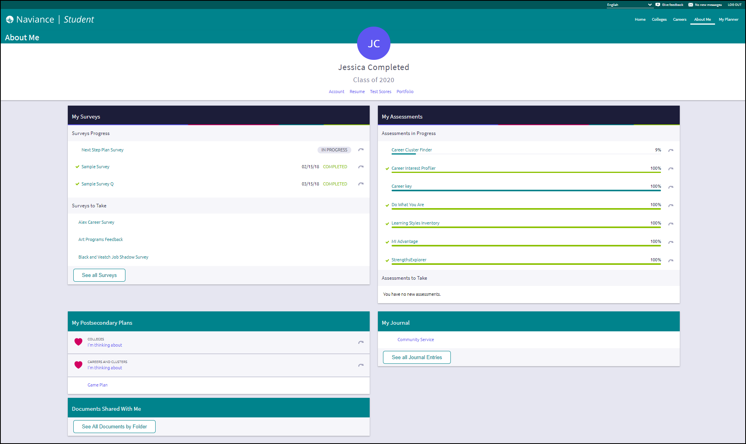
About Me gives you access to an overview of information directly connected to you and your experience in Naviance Student.

My Stuff

Account
View general account information, parent/guardian, and security information. Some information can be edited.

Resume
The resume builder makes creating a resume quick and easy. There is a reference guide on Resume Builder if you need assistance using it to build a resume.

Test Scores
View and edit (if permissions have been granted) your scores for key tests.

Portfolio
The portfolio is a comprehensive report of all the activity associated with you in Naviance Student, including assessment results. This portfolio can be viewed and printed as needed.

My Surveys and My Assessments

My Surveys
View surveys in progress and surveys that still need to be completed. Click a survey to continue or start the survey. The See all Surveys link will bring you to a full list of available surveys.

My Assessments
View assessments you have in progress with a status indicator to identify how far you have come on that assessment. Click on the assessment to complete it. From this list, you can also see assessments that you still have to take.

My Postsecondary Plans
This section of the About Me page gives you quick access to your favorite colleges and careers. If the Game Plan survey has been shared with you by your school, you will also find that here. Click the Game Plan link to open and take the survey.

My Journal
The My Journal section shows the most recent journal entries that have been created. Click See all Journal Entries to view more or create a new one.

View Journal Entries and Comments
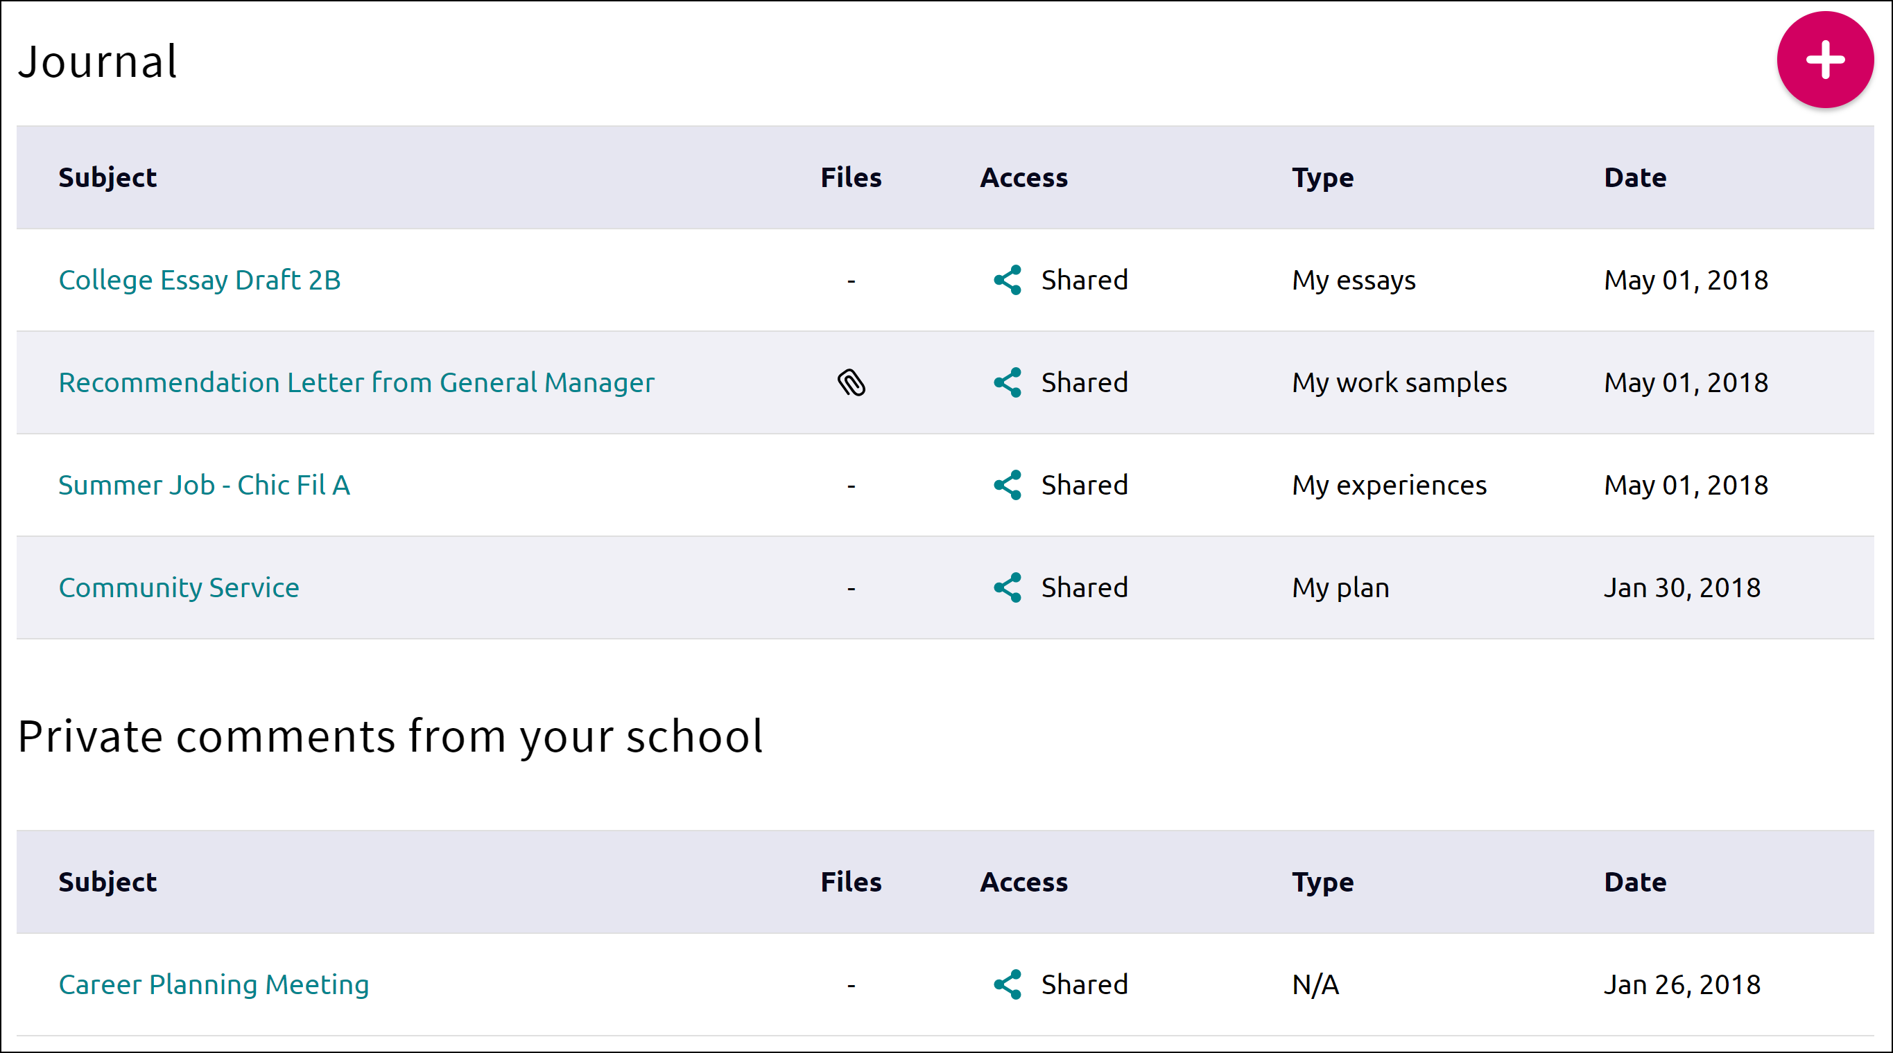
The journal entries are listed from newest to oldest. You can see information about connected files, access given, and the type of entry. Click on a journal entry to open and edit it if needed.
Use the Private Comments from Your School to see entries that have been created by your counselors, teachers or parents for you.

Add a Journal Entry
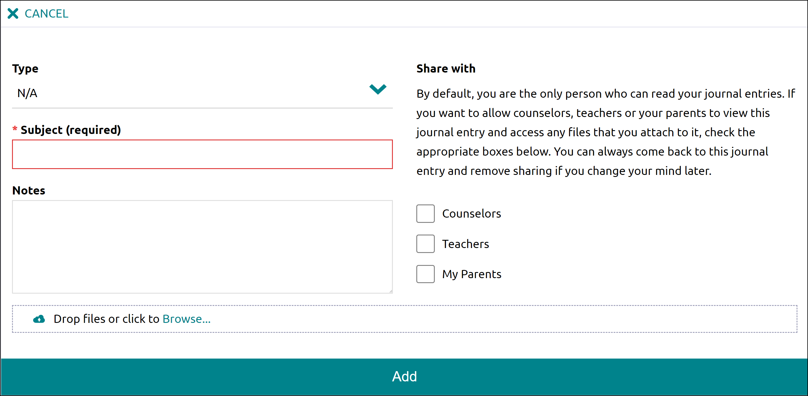
- From the Journal page, click the Add (plus) button.
- Use the drop-down to designate the type of journal entry this will be.
- Enter a subject, notes, and attach any necessary files.
- Use the checkboxes to decide if you want to share the entry with counselors, teachers, or your parents.
- Click Add.

Documents Shared with Me
View any of your recently accessed documents that had been shared with you via a counselor or teacher. Click See All Documents by Folder to browse folders containing documents that a counselor or teacher has shared only with you.

